

**Hannah Leann List – 2010**

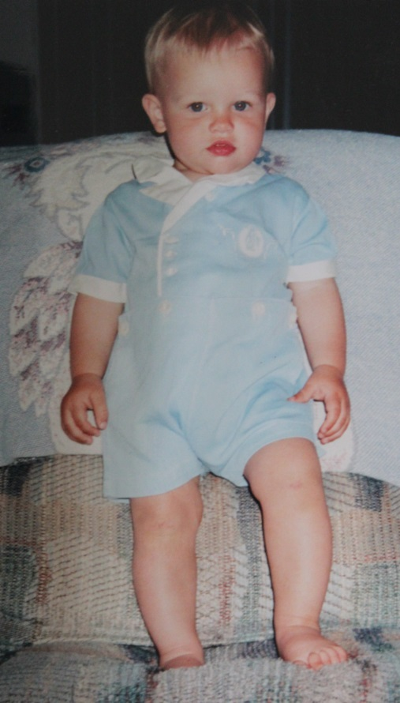

**Alexander Thomas List - 2000**

**clothes worn by David Wolfe List in 1937**